SUMMERVILLE CREDIT UNION · CONSOLIDATED MEMBER GUIDE
Travel Notice

Module: nFinia Digital Banking > More > Travel Notice
01 PRODUCT SUMMARY

The Travel Notice feature lets you notify Summerville Credit Union of upcoming travel so that your card transactions in foreign locations are not flagged as suspicious or blocked. Without a travel notice, unusual activity in a new country may trigger automatic fraud prevention, declining your card.
You can submit a travel notice by selecting the card, specifying travel destinations, and entering the travel dates (year and month). Submitted notices appear in the Travel Itineraries tab, where you can view, edit, or remove them. You can maintain multiple travel itineraries for different trips or destinations simultaneously.

At a Glance
Attribute | Detail
Module | nFinia Digital Banking > More > Travel Notice
Purpose | Prevents fraud blocks on international transactions during travel
Information Required | Card selection, destination(s), travel year and month
Manage Itineraries | View, edit, or remove existing travel notices
Related Features | Location Controls, Card Controls, Card Alerts

02 KEY USE CASES

Use Case | Who Uses It | What They Do | Business Value
Submit a travel notice | Member planning international travel | Selects card, enters destination and dates, saves notice | Card is approved for use in the notified country during the specified period
Add multiple destinations | Member with a multi-country trip | Submits separate notices or adds multiple locations to one itinerary | All destinations covered to prevent declines during the trip
Edit an existing notice | Member whose travel plans changed | Finds the notice in Travel Itineraries and clicks Edit itinerary | Updated dates or destination take effect immediately
Remove a travel notice | Member who cancelled a trip | Finds the notice in Travel Itineraries and clicks Remove itinerary | Notice is deleted and standard transaction rules resume

03 STEP-BY-STEP GUIDE

Navigation: Log in to Summerville Credit Union online banking. From the Dashboard, click More in the top navigation bar, then select Travel Notice.
Step 1 — Arrive at the Dashboard
After logging in, you land on the Dashboard. Click More in the top navigation bar to expand the menu and find Travel Notice. This option is not visible in the main navigation bar by default.
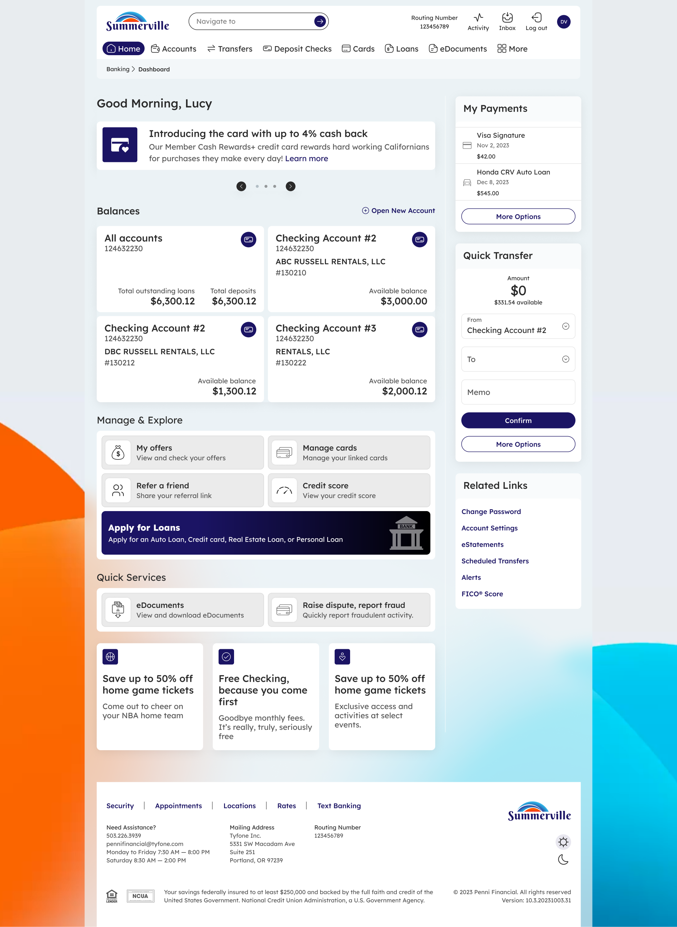
Step 1: Dashboard — click More in the top navigation to find Travel Notice
Step 2 — View Existing Travel Itineraries
The Travel Notice page opens on the Travel Itineraries tab, which shows any travel notices you have already submitted. Each entry displays the card, travel dates, destination, and options to Remove itinerary or Edit itinerary. Click the Set Travel Notice tab to create a new notice.
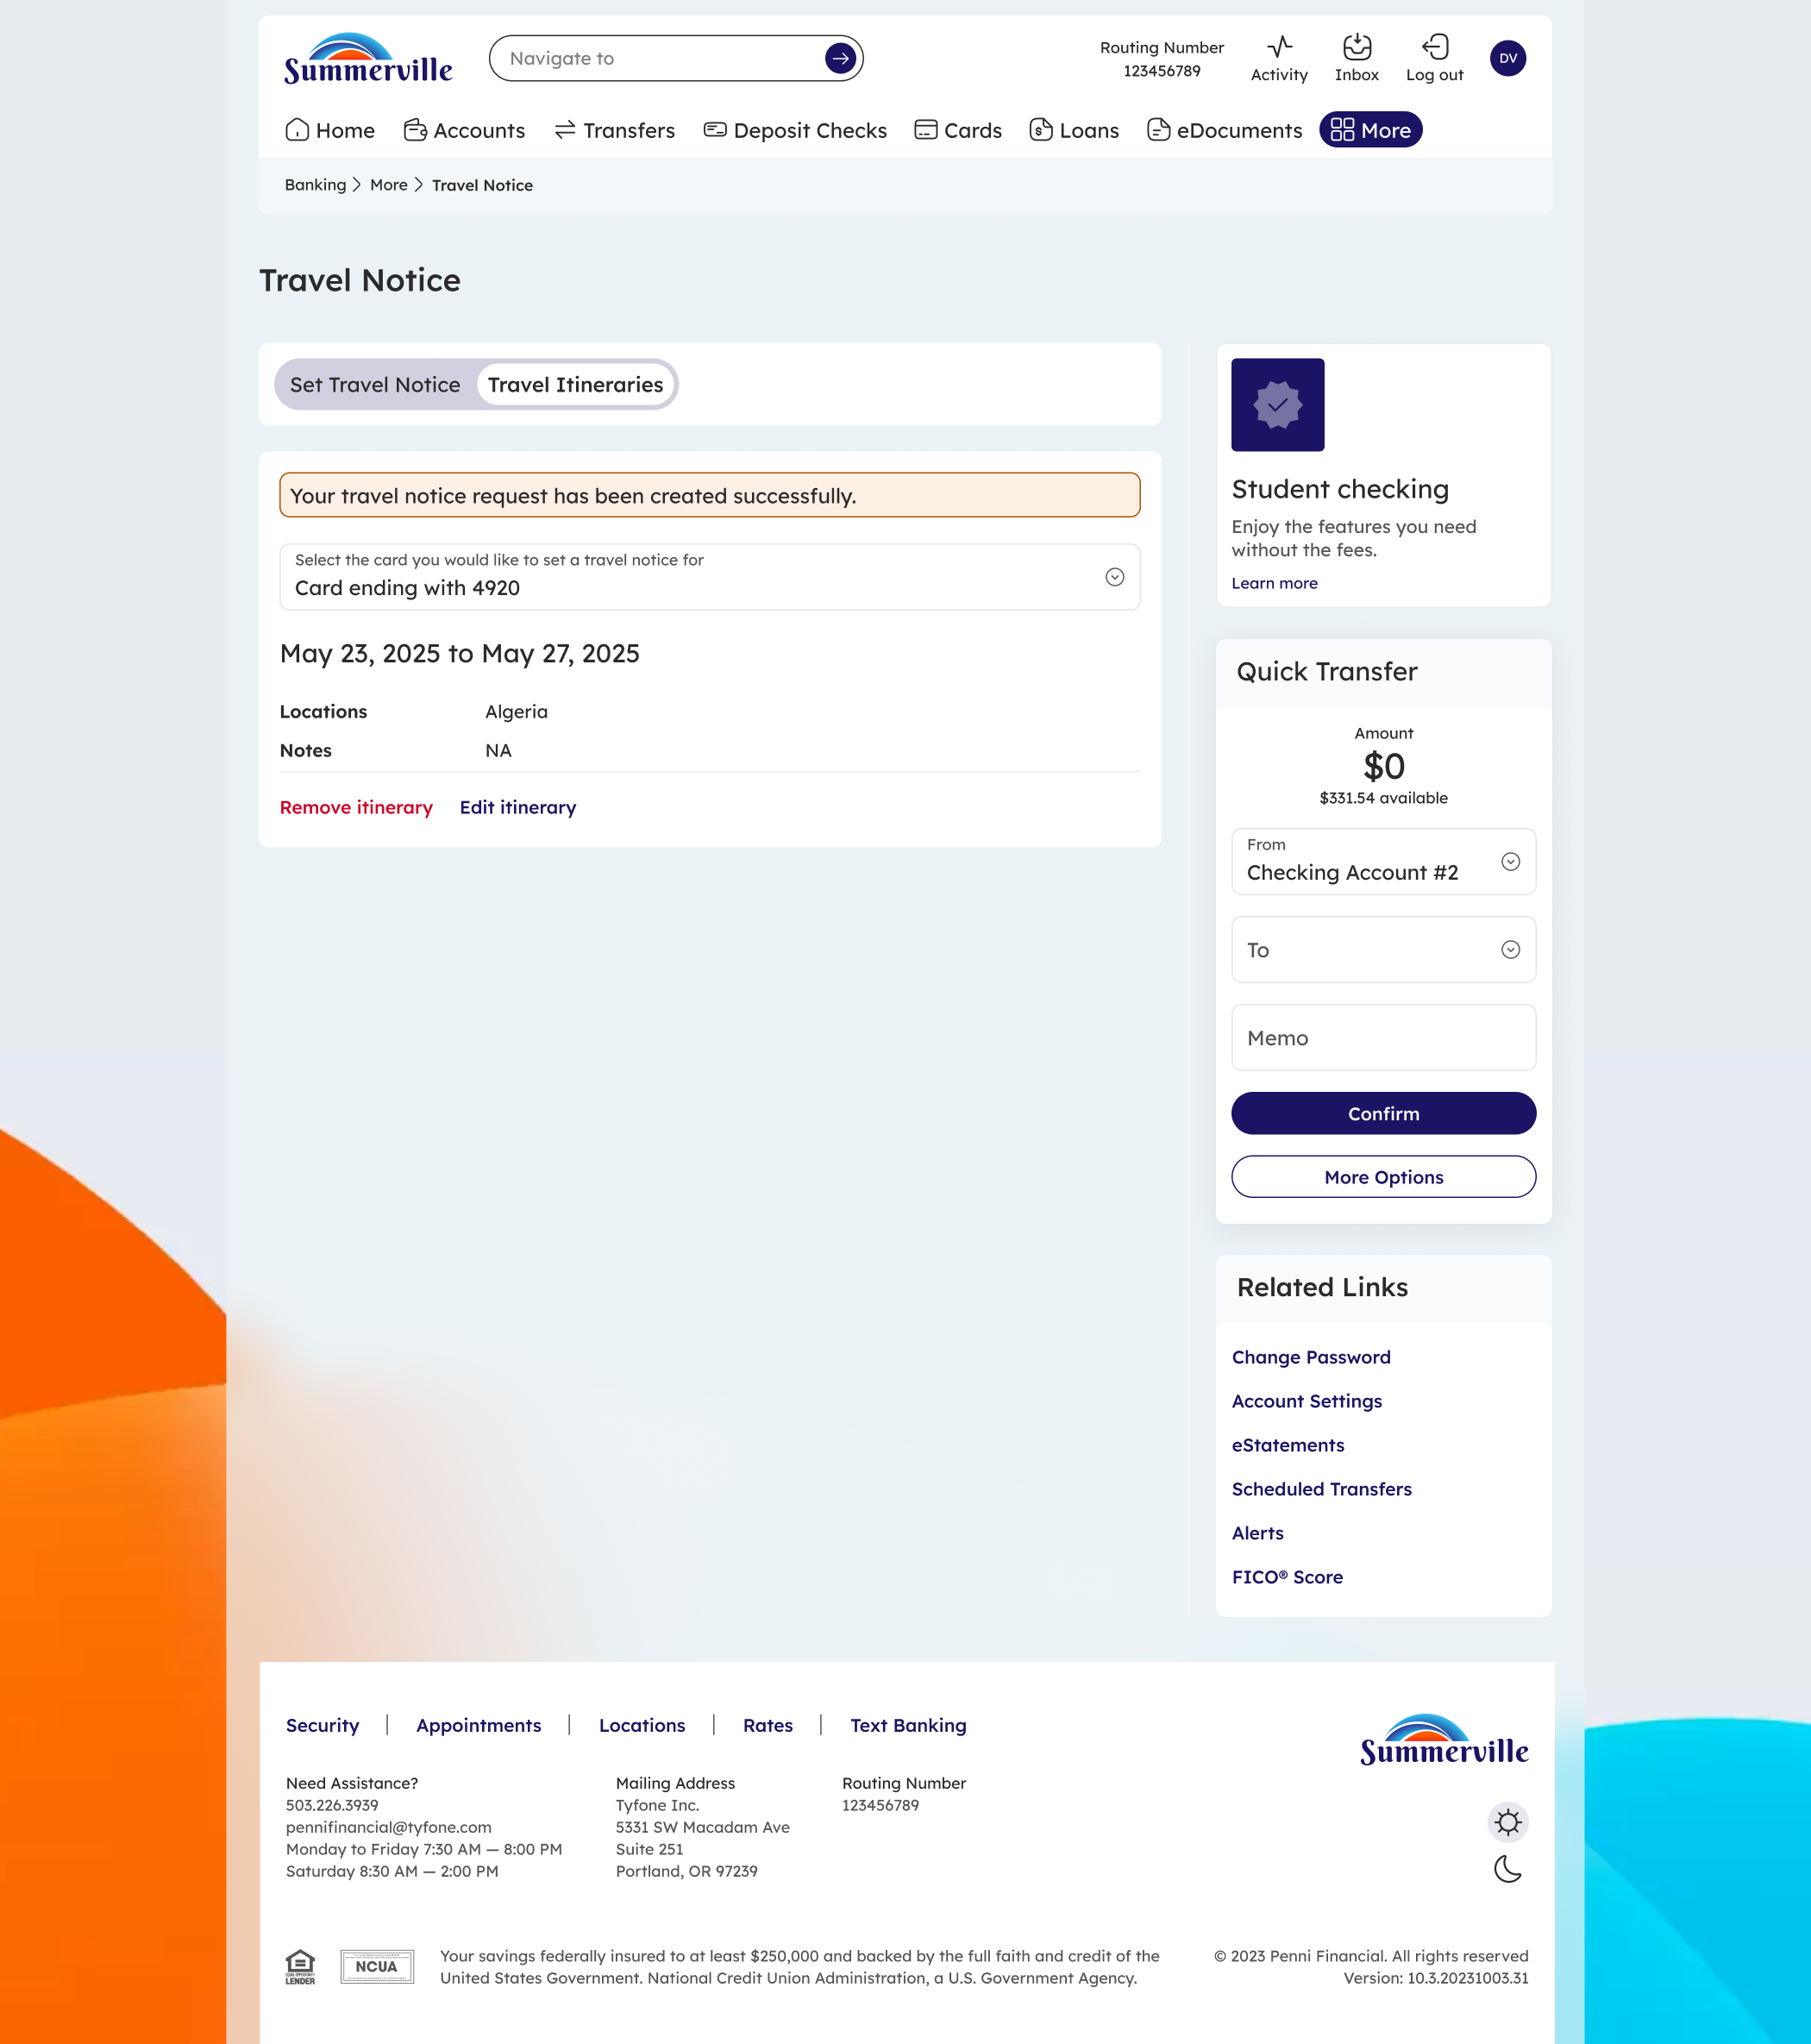
Step 2: Travel Itineraries tab — view, edit, or remove existing travel notices
Step 3 — Set a New Travel Notice
On the Set Travel Notice tab, select the card you will be using for travel, enter the destination location(s), and select the travel year and month. A reminder at the bottom advises that the selected card must be active and enabled for international transactions. Click Save Travel Notice to submit, or Cancel to discard.
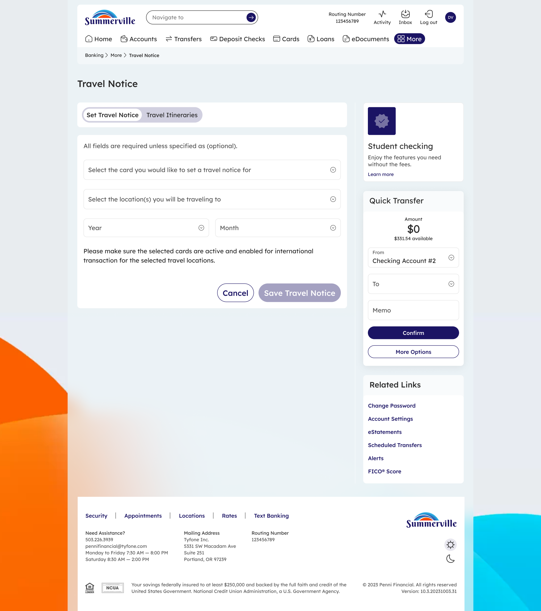
Step 3: Enter your card, destination, and travel dates, then click Save Travel Notice

Tip: Submit your travel notice at least one day before departure. Also check that Location Controls on your card allow international transactions — travel notices and location settings work together to approve your card abroad.

